**5 RECRUITMRNT MATRICES**

* **Time to hire:**

Time to hire measures the time between the moment your eventual hire entered your pipeline (through sourcing or application) and the moment they accepted your job offer. This metric indicates how fast you spotted your best candidate and moved them across the job’s pipeline.

To calculate time to hire, imagine that the day you opened a specific position is Day 1. Then, if your best candidate accepted your job offer on Day 25, and they applied on Day 10, your time to hire is 25-10 = 15.



**What’s a good benchmark for time to hire?**

The moment the best candidate applies, your hiring team should be ready to identify them. Considering that the most talented people are off the market in 10 days, it’s best to aim for the shortest time to hire possible.

**How can we improve time to hire?**

The more efficient your hiring process is, the shorter your time to hire will be. To reduce your time to hire, start by identifying what caused it to be higher than you’d expect.

* Break down your hiring process. Measure how much time it took to move candidates from one stage to another. That way, you can discover whether your hiring team spends too much time on a particular phase.
* Calculate time to hire per team. If there’s one particular team that inflated your average time to hire, talk to the hiring manager to discover the cause.
* Train hiring teams. Both recruiters and hiring managers benefit from interview training, which can help them spot the best candidates for a role more quickly.
* Use templates. Communicate with candidates by crafting effective emails through customizing templates. This can shorten the time you spend on scheduling and answering questions and will also reduce your time to fill.
* **Cost per hire:**

Cost-per-hire (CPH) is one of the most intriguing recruiting metrics. It’s simple to understand, but can be time-consuming to calculate. It’s vital to some, but opaque to others. In this article, we explore its workings and try to determine its value.

The way companies calculated cost-per-hire varied until HR leaders created a standard formula in 2012. The Society of Human Resource Management (SHRM) and the American National Standards Institute (ANSI) were both involved.

Their cost-per-hire formula is quite simple:

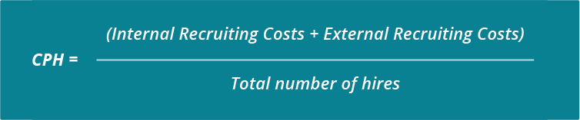

Costs and number of hires both refer to a certain measurement period (e.g. monthly or annually).

* Internal costs:

Internal costs refer to internal staff, capital and organizational costs of the recruitment function. Note that internal costs can include resource allocation from one team to another for recruitment purposes, even if money stays in the company.

* External costs:

External costs refer to any expense that is incurred to external vendors or individuals during the course of recruiting.

* Total number of hires:

Total number of hires might be measured differently across companies. But, generally, companies could include all internal or external hires.

* **Termination during probation / Probation period dismissal:**

Probation period dismissal should be a last resort where you feel that your recruit is not suited to the role and you terminate their contract. Your decision will focus on factors such as their poor performance or timekeeping, failure to fit into the company culture, or even an act of gross misconduct, such as violence, theft, or fraud.

You should go through a full procedure before you make any firm decisions regarding a dismissal.

**Probationary period dismissal procedure:**

* Write to the employee to invite them to a probationary review meeting and tell them that you are considering terminating their contract due to issues with their performance.
* Mention the employee's right to bring a colleague or trade union representative to the meeting.
* Provide evidence to support your concerns.
* Give them the chance to respond to the issues that you raise.
* Decide the outcome—to terminate their contract or extend their probation.
* Give them a copy of the outcome in writing.

When you write to them, mention their right to appeal and the deadline, which you should state in their contract.

Make sure you are fair and consistent with all employees. A paper trail of these steps will give you lots of evidence of reasonable process, which should help you against a claim for wrongful dismissal.

Where possible, you should only end their contract due to unacceptable progress, poor behaviour, or gross misconduct.

**In their first week of working for you, help them by setting out the following:**

* What you expect of them during the probation period, including targets to meet and skills to learn or hone.
* The core values of your business.
* The standards of regular attendance and punctuality.
* Any training or support that will be available for them to develop.
* How you will deal with any issues of performance.
* When the probation review(s) will take place.

Hiring staff costs time and money. The more you help them to understand their role and their duties in their first weeks, the better chance they have to deal with the job’s demands and fulfil your investment.

* **Employee referral hires, Agency hires & Lateral hires:**

1. **Employee referral** is an internal recruitment method employed by organizations to identify potential candidates from their existing employees’ social networks. An employee referral scheme encourages a company’s existing employees to select and recruit the suitable candidates from their social networks. As a reward, the employer typically pays the referring employee a referral bonus.
2. **Recruitment agencies** are private agencies that provide candidates for many large companies and also provide job offers and chances for potential employees and candidates. Based on the job description and criteria set by the company, they select various candidates through different media such as advertisements, job sites, through their websites, job fairs and also through social media.

Staffing agencies contribute to the industry by conducting recruitment drives and staffing potential candidates for organisations, which do not have time, money and the related resources for getting the job done.

1. **Lateral hiring** is a proven way of retaining the talent in the company by moving talent from one department to another (or within same department but different role/team). It's a form of IJP (Internal Job Posting) where company invites applications within the company to move talent to a new role (Not a promotion generally) & allowing the employee to shift his career from one department to another. For example, an Assistant Manager in Operations can be hired for a new role in the company - Assistant Manager - HR.

This is a win win situation for both - Company where the retention is improved and cost for recruitment, training, etc… is saved and Employee where he/she can work for the job profile which interests him more than the current role/profile & motivates him towards the company.

* **Quality of hire:**

Quality of hire refers to the value a new hire brings to your company. The metric is somewhat more abstract than time to fill or time to hire KPIs, but it is also a measure that demonstrates HR analytics efficiency and success at identifying the right applicants for positions of need.

**Why Does It Matter?**

For any business, the goal of a new hire isn’t to simply fill positions with workers, but to ensure that new hires stay at the company and provide real value to justify the investment in them.

The quality of hire KPI helps you determine not just if a position was filled, but if it was filled by the right candidate. This is essential for companies considering it helps them establish if their hiring processes are consistently finding the right candidates, and if those hires are turning into successful, productive employees.

**How Do You Measure the KPI?**

Because quality of hire is a somewhat subjective KPI (it may change from company to company), there are several factors that can be applied to gain a clear picture of the metric. In many cases, quality of hire can be measured as a composite of factors such as retention, how long the position took to fill, how satisfied hiring managers are, as well as job performance, ramp-up time (how long it takes to reach full productivity), and engagement.

**What Sources Would You Use to Measure the KPI?**

To track quality of hire, you can draw from sources of data that include hiring processes (time to hire, retention), performance (productivity, engagement, quality), and even company culture (employee fit, satisfaction).

**Explanation of Charts**

1. **Employee Count by Gender:**

This is a “pie chart” showing percentage of male and female employees in total employee count of a company. There are 60% (882) male employees and 40% (588) female employees. That means male to female ratio is 6:4.

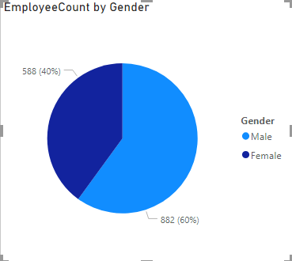

1. **Average Years at Company by Job Role:**

This is a “donut chart” showing average years at a company by job roles. From observation we can conclude that Managers have highest average years at a company which is approximately 14.5 years and Sales Representative have lowest average years at a company which is approximately 3 years. Employees at higher posts or job roles serve for more period as compared employees at lower posts or job roles.

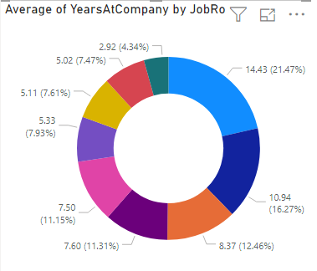

1. **Employee Count by Salary Hike and Performance Rating:**

This is a “treemap” showing relation between Salary hike and Performance Rating of employees. From this treemap, we can conclude that employees with higher performance rating are getting higher percentage of salary hike as compared to employees with lower performance rating. This shows that company is paying salaries according to their employee’s performance.

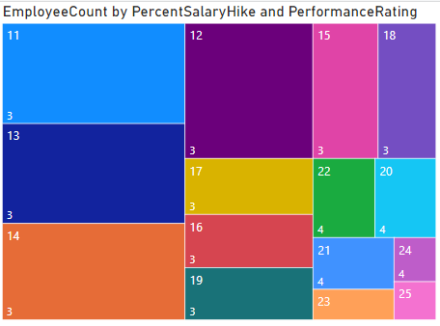

1. **Percentage of employees by Department and Attrition:**

This is a “clustered column chart” showing Department-wise Attrition rate. Here the highest attrition rate is 9.05% in Research & Development Department followed by 6.26% in Sales Department and 0.82% in Human Resources Department.

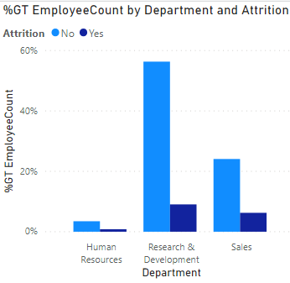

1. **Employee Count by Job Role and Job Satisfaction:**

This is a “stacked column chart” showing relation between Job Role and Job Satisfaction level. There are 4 job satisfaction levels for each job role. This chart is showing count of employees in each job role and each satisfaction level.

